Challenge: Walkie Hackie

# Challenge Description :

**Our agents got caught during a mission and found that the guards are using old walkie-talkies for their communication. The field team captured their transmissions. Can you interrupt their communication to help our agents escape from the guards?**

# Context :

## Just Analyze a web-application, You are also given four radiofrequency signal capture files. You must decode these radio transmissions and craft the correct payload to send to the transmit endpoint to get the Flag.

# Flag :

* **First Install the software and install the files. Drag the file into Logic2 to start analyzing it and to view the contents of it .**

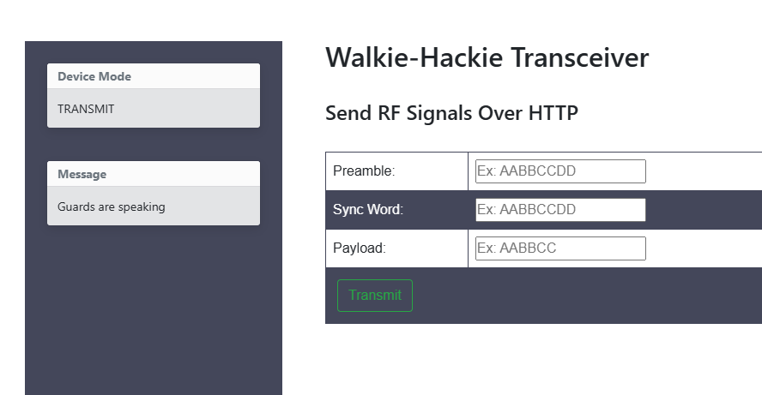

* **Filtering the radiofrequency signal file to get a form of data we extract the signal pulses as bits. Basically Converting Pulses to a bunch of Ones and Zeros.**
* **After getting the bits from the radiofrequency signal file we then convert the bits to a hexadecimal format using python.**
* **I did all this in Kali linux using pre-installed tools to filter out the radio transmissions like Gqrx and inspectrum.**
* **Each radiofrequency signal capture file gave out a different result after extracting the bits to hexadecimal.**
* **The format for each radiofrequency signal is made up of three parts:**
  + - * **0xaaaaaaaa 73214693 a1ff14**
      * **0xaaaaaaaa 73214693 b1ff57**
      * **0xaaaaaaaa 73214693 a2ff84**
      * **0xaaaaaaaa 73214693 b2ff24**
* **To get the flag we will need to enter this data into the website as its similar to its current placeholders,**
* **Acknowledging this we need to generate the last part of the signal, the Payload.**
* **Looking at the results we already got we can justify that the middle part will be the same as [ FF ] making this a lot easier. we will only need to brute force the first and last section of the payload.**
* **Getting a quick one-liner to generate the characters into a function to use with curl, this is also easier to setup with burp-suite.**
* **Finally getting the Right payload should end up in a 200 Status response, you can also just make a request to get the flag with the right payload if the page doesn't render it.**

**[ 94.237.57.229:42877/transmit -d 'pa=aaaaaaaa&sw=73214693&pl=00fff9 ]**

* **The Flag after finding the right payload is : HTB{B4s1c_r4d10_fund4s}**

